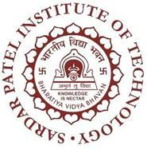 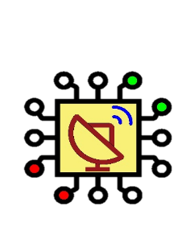

***Bharatiya Vidya Bhavan’s***

**Sardar Patel Institute of Technology**

**(*An Empowered Autonomous Institute Affiliated to University of Mumbai*)**

**Munshi Nagar, Andheri (W), Mumbai-400058**

**Electronics & Telecommunication Engineering Department**

**Vision**

“To graduate professionally competent Electronics and Telecommunication engineers with research aptitude and social sensitivity.”

**Mission**

* To innovate constantly and adopt teaching, learning, evaluation strategies to suit the learners, and ensure academic and research conducive infrastructure.
* To ensure fruitful collaborations with academia and industry for excellence in academic and research.
* To undertake the continuous value addition of faculty and staff with suitable empowerment policies.
* To inculcate sensitivity to societal issues, communication skills and teamwork, lifelong learning attitude, and relevant skills amongst the learners.
* To ensure holistic, flexibility, inclusivity and all rounded development of the learners.

**Program Education Objectives (PEO)**

* Establish themselves in their chosen career paths by demonstrating technical competence in design, analysis, and maintenance of electronics systems, signal processing, communication systems, computer network, etc.
* Demonstrate leadership, communication, and interpersonal skills, creativity and innovation, teamwork, and excellent project and finance management skills.
* Contribute towards the next generation of electronics technologies with creative and innovative practices.
* Demonstrate zeal towards lifelong learning, values, ethics, sensitivity to global problems, and prove to be dutiful citizens for society.

**Programme Specific Outcomes (PSO)**

* The ability to understand, analyze, design, prototype, maintain and troubleshoot circuits and systems in the domain of communication, signal processing, embedded and power electronics.
* The ability to demonstrate good communication skills, teamwork, project and finance management skills, sensitivity towards environment and society, and attitude of lifelong learning.